Healthy Country Planning

Self-Assessment Tool

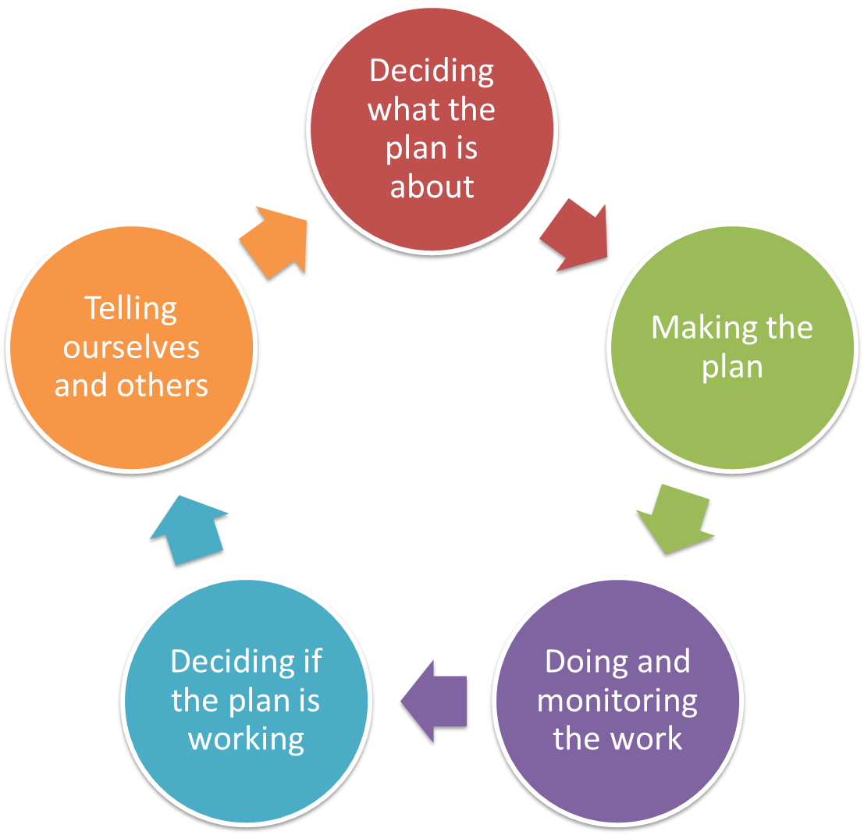

A Tool for the use of teams to check their progress in the development and implementation of their Plans.

Based on the CAP Self-Assessment Tool, but modified after for use in Healthy Country Planning and as part of the development of materials to ‘Close the Loop’.

Acknowledgements
This document is based on an original by CCNet. It has been modified and amplified after many discussions and as a result of a workshop in Melbourne, Australia, December 2014.

Instructions for Use

This tool is best used in a team for regular reflection on the progress of your planning and plans, and to see what areas of the plan and its use could be improved.

The tool will give you three things:
- An indication of what is ‘best practice’ for a step in the Open Standards
- An assessment of where you are as a team against that ‘best practice’
- A way of tracking your improvement over time in your planning and the use of your plan.

To use the tool:
- Bring your planning team together
- Discuss each step. Be as honest as you can – the purpose of this is to help you improve
- Decide what ‘rank’ you have achieved for each step
  - Look at each Criteria in the left hand column
  - Read across the row to see which rank best fits
    - COMPLETE: The criteria has been met fully, there is no more to do
    - ON TRACK: There are still a few things to do but most are done
    - SMALL ISSUES: There are a few problems that need to be addressed
    - BIG ISSUES: There are some big problems to address – the criteria is not met
  - If the team has not reached this Step yet, then just note it as STILL TO DO
  - Mark the box that you think is best
  - When you have discussed each criteria, see which column has the most boxes marked
  - This is your rating – record this at the bottom of the page
- Record the good things you have completed
- Decide if you need to do any more to improve
- Record the changes you need to make to move to the next level

1. Pre-Planning |  |  | OS 1A: Define the initial project team
Key Questions | Why do we need a plan? Who is it for? Is there a project team with clear jobs? Who else should be involved in the planning and implementation? What are the main steps to develop the plan? What resources are needed and available?
CRITERIA | COMPLETE | ON TRACK |  | SMALL ISSUES | BIG ISSUES
PURPOSE | All the planning team understands why the plan is being done and who for | All the planning team understands why the plan is being done and who for |  | The purpose of the plan is mostly clear | The purpose of the plan is not clear
TIMETABLE | All parties have agreed a timetable and budget to make the plan | All parties have agreed a timetable and budget to make the plan |  | A timetable and budget to make the plan is not agreed and missing key steps | The steps to develop the plan have not been identified
RESOURCES | All the funds and people to support the planning are available. | Most of the funds and people to support the planning are available |  | The funds and people required to support the planning are not available/secured | No / very few resources
LEADERSHIP | There is a clear project leader and team with clearly assigned jobs | There is a project leader and team with jobs |  | A team is not clear and missing key people | A team is not clear and missing key people
PARTNERS | Partners and stakeholders are engaged, and understand their roles | Partners and stakeholders are there as advisors |  | There are gaps in representation of stakeholders/ partners | Stakeholders not known / engaged
COMMUNITY | Project has strong local community relations | Project has some local community relations |  | Poor community relationships | No community relationships
AGREEMENT | A written Project Charter / Agreement is available and understood | No written Project Charter / Agreement |  | No written Project Charter / Agreement | No written Project Charter / Agreement
Our Rating: | Positive Findings:  Opportunities for improvement:  Recommendations:  Notes:

2. Vision/Dream, Scope & targets |  |  | OS 1B: Define Scope, Vision and Targets
Key Questions | Does the project have a clear scope? Does it fit into a regional picture? Is there a clear vision/dream? Have targets (important things) been selected?
CRITERIA | COMPLETE | ON TRACK |  | SMALL ISSUES | BIG ISSUES
VISION | A clear Vision/dream is stated for the project and reflects the main reason this project area was chosen | A Vision/dream is stated for the project, but it may not meet all criteria of being general, brief, and achievable. |  | An overarching vision/dream is stated for the project, but it may not be inspiring, general, brief, or achievable | Overall vision/dream is lacking or unclear
SCOPE | There is a clear map(s) and description of the project and understood by the Project Team. | There is a clear map(s) and description of the project and understood by the Project Team. |  | There is a general idea of scope/ area of project but a map or description may not be widely-shared, | Scope not agreed
TARGETS | The reason for selecting the targets to represent the project is well recorded | The reason for selecting the targets to represent the project is well recorded |  | Targets are selected, but the reason may not be given or is unclear | Targets are broad and unclear
NESTED TARGETS | Nested targets are linked to targets, and how the nested targets are connected to the targets is clear and written | Nested targets are linked to targets, and the relationship of nested targets to targets is clear |  | Nested targets are not listed or relationship of nested targets to targets may not be evident | No nested targets recorded
MAPPING | Maps are effective and show location of targets (important things), other features | The project area is mapped and some targets and threats are being mapped |  | The project area is mapped but no targets and threats are mapped | No map
Our Rating: | Positive Findings:  Opportunities for improvement:  Recommendations:  Notes:

3. Assess health of targets |  |  | OS 1B: Define Scope, Vision and Targets
Key Questions | What defines health (viability)? How far off is the current health from what we want? Which targets (important things) are most in need of attention?
CRITERIA | COMPLETE | ON TRACK |  | SMALL ISSUES | BIG ISSUES
ATTRIBUTES SELECTED | Team has selected at least one attribute for each target. | Team has selected at least one attribute for most targets |  | Team has selected one or more attribute for some targets | Attributes / Indicators have not been selected for most of the targets
ATTRIBUTES QUALITY | Attributes represent a reasonable mix of key environmental needs and cultural perspectives. Nested targets were thought about when selecting attributes | Attributes represent a reasonable mix of key environmental needs and cultural perspectives. Nested targets were thought about when selecting attributes |  | Attributes only present for a few targets and / or do not take in all perspectives | No attributes
INDICATORS SELECTED | At least one indicator for each attribute / target. | At least one indicator for many attributes or targets |  | Indicator(s) are selected for some attributes or targets | Most targets do not have indicators
INDICATOR QUALITY | Indicators are sensitive enough to detect change, and can (and will) be measured for all targets. | Indicators are sensitive enough to detect change, and can (and will) be measured for most targets. |  | Indicators are unclear for most targets | Indicators are missing
INDICATOR STATUS | When available, a best estimate of current and desired status is given for most indicators | When available, a best estimate of current and desired status is given for many indicators, even if it is a guess |  | Current and desired status may be missing for many indicators. | Indicators missinf
DOCUMENT-ATION | Literature used and / or experts interviewed, and rationale for choice of attributes, indicators, indicator ratings, and current and desired status is documented | Literature used and / or experts interviewed, and rationale for choice of attributes, indicators, indicator ratings, and current and desired status is documented |  | Attributes and indicators have been selected by the team based on their best knowledge but may not have been rigorously assessed. | Attributes and indicators have no clear basis
Our Rating: | Positive Findings:  Opportunities for improvement:  Recommendations:  Notes:

4. Critical threats – problems & causes |  |  |  | OS 1C: Define Critical Threats
Key Questions | What are the problems that stop the targets being healthy? What are the causes of the problems? What are the most critical ones?
CRITERIA | COMPLETE | ON TRACK | SMALL ISSUES |  | BIG ISSUES
PROBLEMS | A comprehensive list of problems is given for each target. | A comprehensive list of problems is given for each target | A comprehensive list of problems is given for some targets |  | Threats are poorly identified if at all, or are not directly related to targets
CAUSES | A comprehensive list of causes of problem is given for each target (or at least a distinction between problems and causes of problem). | A comprehensive list of causes of problem is given for each target (or at least a distinction between problems and causes of problem). | A comprehensive list of causes is given for some targets |  | Causes and problems are not differentiated and/or not related to targets
RANKING | The causes of problems affecting each target are ranked and the critical threats affecting the overall project identified | The causes of problem affecting each target are ranked and the critical threats affecting the overall project identified | Some ranking of which threats are most critical has been made, although it may not be systematic ranking |  | No ranking
AGREEMENT | Rankings are clearly agreed to by the Project Team, including partners and l experts | Rankings are clearly agreed to by the Project Team | Rankings are not yet agreed to by the Project Team |  | Rankings are not yet agreed to by the Project Team
DOCUMENT-ATION | Documentation of information and assumptions made is presented in the workbook or plan text. | Documentation of information and assumptions made is recorded. | Documentation of information and assumptions made is not recorded. |  | Documentation of information and assumptions made is not recorded.
Our Rating: | Positive Findings:  Opportunities for improvement:  Recommendations:  Notes:

5. Conduct Situation Analysis |  |  | OS 1D: Complete Situation Analysis
Key Questions | How are threats and opportunities related to each other and to stakeholders? Do we understand how things impact our targets well enough to design good strategies? Can we see points where we can intervene?
CRITERIA | COMPLETE | ON TRACK |  | SMALL ISSUES | BIG ISSUES
ANALYSIS COMPLETED | One or more diagrams or descriptions of the situation shows how targets, critical threats, causes, opportunities and stakeholders are linked | One or more diagrams or descriptions of the situation shows how targets, critical threats, causes, opportunities and stakeholders are linked |  | One or more diagrams or descriptions of the situation only shows how some targets, critical threats, causes, opportunities and stakeholders are linked | No situation analysis
SIMPLICITY | Diagram is simple and does not show too much detail, but helps understand the situation and identify strategies and monitoring | Diagram helps understand the situation and identify strategies and monitoring |  | Diagram is too simple or too complex to help understand the situation and identify strategies and monitoring | No situation analysis
UNDERSTAND-ING | Team members understand and can communicate the situation well. | Team members understand and can communicate the situation well. |  | Team members cannot communicate the situation well. | Team members have a weak understanding of the situation
TEAM | The team used people different skills and Stakeholders/ partners to help develop the analysis | The team used people different skills and Stakeholders/ partners to help develop the analysis |  | The analysis was conducted by only a few people who may not have sufficient knowledge of all the situation, | No analysis conducted
COMMUNICATION | The analysis could be used to help communicate the situation and our work to key stakeholders. | The analysis could be used to help communicate the situation and our work to key stakeholders. |  | The analysis is not likely to help with communication in its present form. | The analysis is not likely to help with communication in its present form.
Our Rating: | Positive Findings:  Opportunities for improvement:  Recommendations:  Notes:

6. Goals & Strategies |  |  | OS 2A: Develop Strategic Plan
Key Questions | Have SMART goals been set? Will goals and strategies make sure that the biggest threats are fixed and targets are maintained or made healthier? Are the goals written so the project team will be able to know if they are successful?
CRITERIA | COMPLETE | ON TRACK |  | SMALL ISSUES | BIG ISSUES
GOALS | Goals for all critical threats and degraded targets are presented | Goals for most critical threats and degraded targets are presented |  | Goals for some critical threats or degraded targets are presented | Critical threats or degraded targets are not addressed
SMART | Goals meet SMART criteria and are politically, socially, and ecologically appropriate | Goals meet most of SMART criteria |  | Goals may not meet several of SMART criteria | Goals are not SMART
ACHIEVABLE | The number of goals is feasible given project resources. | The number of goals is feasible given project resources |  | Goals may be too ambitious OR not ambitious enough | Goals are written too poorly to know if they are achievable
PARTNERS | Partners are involved in the development of at least some goals | Partners are involved in the development of at least some goals |  | No partners involved in the development of goals | No partners involved in the development of goals
LINKED | All goals are explicitly linked to the situation analysis, if one is available | Most goals are explicitly linked to the situation analysis, if one is available |  | Some goals are explicitly linked to the situation analysis, if one is available | No goals are explicitly linked to the situation analysis, if one is available
STRATEGIES | Each goal has one or more strategies linked to it | Each goal has one or more strategies linked to it |  | Some goals may not have strategies linked to them | Strategies not identified
LINKED | All strategies are linked to goals | Most strategies are linked to goals |  | Some strategies are linked to goals | No strategies are linked to goals
FEASIBLE | All Strategies are high-leverage and feasible | Most Strategies are high-leverage and feasible |  | Some Strategies are high-leverage and feasible | No Strategies are high-leverage and feasible
RANKED | Strategies are ranked for benefits, cost, and feasibility | Most feasible strategies are ranked for benefits, cost, and feasibility |  | Strategies have not been systematically ranked for benefits, cost and feasibility. | Strategies have not been ranked
Our Rating: | Positive Findings:  Opportunities for improvement:  Recommendations:  Notes:

7. Results Chains–The Theory Of Change |  |  |  | OS 2A: Develop Strategic Plan
Key Questions | What specific steps are you going to take to achieve your Goals? Why do you think the steps in your plan of action will work? What do you want to happen when you complete each step? How will you know when you are done?
CRITERIA | COMPLETE | ON TRACK | SMALL ISSUES |  | BIG ISSUES
LOGICAL | There are clear and easily understood results chains outlining how all strategies will actually help to reduce threats or make targets healthier | There are clear and easily understood results chains outlining how most strategies will actually help to reduce threats or make targets healthier | The results chains have some gaps and are not clear on how they will achieve project goals |  | Team members have a weak understanding of how strategies will ultimately lead to achieving the project goals
CLEAR STEPS | Results chains are developed for nearly strategies including the steps needed to get them to work. | Results chains are developed for nearly all strategies including the steps needed to get them to work. | Results chains have been developed for some strategies, including some steps |  | Results chains have not been developed
ASSUMPTIONS | The assumptions in the result chain are clearly identified and understood | The assumptions in most result chains are identified and documented | Some assumptions in the results chains have been identified, but there are still critical gaps in understanding |  | No assumptions identified
MONITORING | The critical areas where the chain is uncertain have been identified and prioritized for monitoring | The critical areas where the chain is uncertain have been identified for monitoring | The critical areas where the chain is uncertain have not been identified |  | The chain is not clear enough to identify uncertainty
MILESTONES | Objectives have been identified where appropriate to make milestones | Some objectives have been identified where appropriate to make milestones | The results chains do not have interim goals or indicators identified |  | The chain is not clear enough to identify milestones
INDICATORS | Indicators for monitoring have been identified and prioritised | Indicators for monitoring have been identified | Not all indicators for monitoring have been identified |  | No indicators for monitoring have been identified
Our Rating: | Positive Findings:  Opportunities for improvement:  Recommendations:  Notes:

8. Establish Measures |  |  |  | OS 2B: Develop Monitoring Plan
Key Questions | Will it be clear if progress is being made? How will we know if threats are better or worse? How will we know if targets are better or worse? Do the indicators link actions and Goals? How are we going to tell people about the results?
CRITERIA | COMPLETE | ON TRACK | SMALL ISSUES |  | BIG ISSUES
IDENTIFIED | Indicators are described for:  - All goals (strategy effectiveness)  - Key threats and targets (status). | Indicators are described for:  - All goals (strategy effectiveness)  - Key threats and targets (status). | Indicators are described but many goals, critical threats, and targets are not the subject of monitoring |  | Indicators and monitoring, if described, are not tied to essential plan elements
LINKAGE | Indicators are closely linked to all goals, threats, or targets | Indicators are closely linked to most goals, threats, or targets | Indicators are linked to some goals, threats, or targets |  | Indicators are not linked to plan elements
METHOD | Monitoring includes a description of monitoring methods for nearly all high priority indicators | Monitoring includes a description of monitoring methods for most high priority indicators | The monitoring plan may include very little or no detail on proposed methods |  | No methods recorded
APPROPRIATE | Nearly all indicators are sensitive, measurable, precise, consistent, cost-effective, timely in response, at an appropriate scale | Most indicators are sensitive, measurable, precise, consistent, cost-effective, timely in response, at an appropriate scale | Most indicators are not sensitive, measurable, precise, consistent, cost-effective, timely in response, at an appropriate scale |  | Very few or no indicators
FEASIBILITY | The monitoring is feasible given project resources. | The monitoring is feasible given project resources. | The monitoring is either too ambitious given project resources, or it is too unclear to budget |  | Insufficient information to make an assessment of feasibility
PRIORITIS-ATION | Monitoring indicators are prioritized | Monitoring indicators are prioritized | Some indicators have been prioritized |  | No prioritising
SOCIAL ELEMENTS | If needed social and other sciences are included | If needed social and other sciences are included with sufficient rigour | If needed social and other sciences are included but vague |  | Social and other sciences are needed but not included
RESULT CHAIN | All monitoring indicators are explicitly linked to the results chain | Most monitoring indicators are explicitly linked to the results chain | Some monitoring indicators are explicitly linked to the results chain |  | No monitoring indicators are linked to the results chain
Our Rating: | Positive Findings:  Opportunities for improvement:  Recommendations:  Notes:

9. Work Plans – Actions, Time & Budget |  |  |  | OS 3A/B: Develop Short-term work plan / Budget
Key Questions | Is there a detailed plan outlining actions and monitoring? Who is responsible for each step? What is the timeline for the plan? What resources are needed, including people and money? Are there enough resources allocated for the implementation of actions and monitoring?
CRITERIA | COMPLETE | ON TRACK | SMALL ISSUES |  | BIG ISSUES
ACTIONS | Major actions and monitoring tasks have been developed, linked to the planning documents, and available to everyone involved in implementing the plan. | Major actions and monitoring tasks have been developed, linked to the planning documents, but are not available to everyone involved in implementing the plan. | Some actions have been identified |  | Actions and monitoring tasks have not been identified
ALLOCATION | Steps and tasks are assigned to specific individual(s) with a timeline. Roles and responsibilities for tasks are agreed by people that will be performing them | Most steps and tasks assigned to specific individual(s) with a rough timeline. Roles and responsibilities for tasks are agreed | Few assignments made or steps budgeted. |  | No assignments made or steps budgeted.
CAPACITY | Assessment of funding, staffing, leadership, and external resources exists and is current | Assessment of funding, staffing, leadership, and external resources exists and is current | Assessments have been made at some time but not necessarily current |  | No assessments made
BUDGET | A detailed project budget exists and is used on a regular basis | At least a rough project budget has been developed | Most items unbudgeted |  | No budget
DATA | Data management and analysis is planned in advance
COMMUNICA-TION | Communication of results planned including audiences and communications products for each
Our Rating: | Positive Findings:  Opportunities for improvement:  Recommendations:  Notes:

10. Implement |  |  |  | OS 3C: Implement Plans
Key Questions | Is the plan being implemented? Does it get support from partners/ stakeholders/ upper management/ funding causes?
CRITERIA | COMPLETE | ON TRACK | SMALL ISSUES |  | BIG ISSUES
IMPLEMENT ACTIONS | Actions follow strategies and plan is adjusted as necessary and with good rationale | Key actions in plan are being implemented (or have been implemented) | Some of actions in plan are being implemented (or have been implemented). |  | Actions and monitoring identified in plan have not been implemented to any degree
MONITORING | Monitoring program follows indicators and methods described in plan and/or plan is adjusted as necessary and with good rationale | Priority monitoring is being implemented (or has been implemented). | Some of monitoring in plan is being implemented (or has been implemented).
COMMUNICATE | Partners/ stakeholders/ upper management/ funders are continually educated about the plan and are involved with, or at least informed of, implementation and monitoring status | Team members are regularly communicating with each other and with at least some of the key partners and managers or funders | Some communication is occurring |  | Very little communication
SUSTAIN | Sustainable causes of funding are available and planned | Funding is available and secured for at least the next 2-3 years for most key actions | Only some actions are funded for the next year or beyond |  | Funding yet to be identified and found
Our Rating: | Positive Findings:  Opportunities for improvement:  Recommendations:  Notes:

11. Review the Plan |  |  |  | OS 4ABC: Analyze, Use, Adapt
Key Questions | What are our monitoring data telling us about our project? What should we be doing differently? How will we capture what we have learned? How can we make sure other people benefit from what we have learned?
CRITERIA | COMPLETE | ON TRACK | SMALL ISSUES |  | BIG ISSUES
ANALYZE | Data has been analysed and used to update health and threat assessments, and modify to your goals, strategic actions and work and monitoring plans | Data has been analysed and used to update and refine goals and strategies | Some data has been analysed, and may have been used to update and refine goals or strategies |  | No review of the plan has taken place
UPDATE | Project documents are updated regularly | Project documents have been updated | Project documents have not been updated
SUMMARIES | Summaries of what you have learned, focusing on both process and results have been developed | A summary of what you have learnt, has been developed | No summary has been developed of what has been learnt
COMMUNICATE | Appropriate communication outputs for each key audience | Some communication of results has occurred | There has not been any coordinated communication of outputs
Our Rating: | Positive Findings:  Opportunities for improvement:  Recommendations:  Notes:

12. Learn & Share |  |  |  | OS 4ABC: Analyze, Use, Adapt
Key Questions | Are results being regularly and clearly communicated with partners, stakeholders, supporters and other audiences? Does the team periodically review and communicate lessons learnt?
CRITERIA | COMPLETE | ON TRACK | SMALL ISSUES |  | BIG ISSUES
VARIETY | A variety of communication mechanisms are used to reach a broad range of supporters and potential supporters | Communication products are tailored for each key audience. Interpretation is made as clear and practical as possible to all audiences, but conclusions are not overstated | Monitoring data may be summarized, but not adequately shared or not communicated in a manner suitable to different audiences. |  | Project outputs and outcomes results not summarised and communicated
SHARING | Joint meetings with project partners, stakeholders and supporters are held periodically | Progress and results are regularly shared with key audiences | Modifications to Objectives and actions may be made, but rationale not shared. |  | Monitoring data not shared with appropriate audiences
REGULAR REVIEW | The team periodically reviews lessons learned and incorporates findings into updates of the plan, and clearly documents results in a way that can be shared with other teams and organisations | The team periodically reviews lessons learned and incorporates findings into updates of the plan, and documents results | Some documentation of the lessons learned |  | No documentation of the lessons learned
Our Rating: | Positive Findings:  Opportunities for improvement:  Recommendations:  Notes:

