Protected Areas Learning and Research Collaboration
Open Standards Short Course
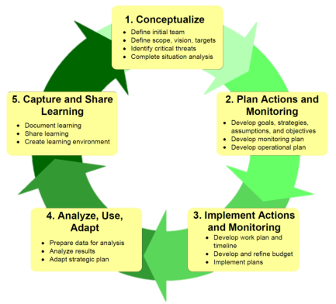
Exercise: Goals and Objectives
TIMING: 65 minutes
WHY WE ARE DOING THIS EXERCISE:
To develop Goals that help to realise the Vision.
A goal is an outcome statement that describes:
An improvement of the health of a target (Poor or Fair)
- Health Goals should typically describe the “Good” rating for an attribute
A reduction of a critical threat (Very High or High)
- Threat Goals should describe what is required to reduce a threat to at least a “Medium” ranking
We want to get the colours in health and threats tables from Red & Yellow to Green.
TASK
- Look at your Target Health table
  - Pick two targets that are a priority for you.
Good ones to pick are where the health is Poor or Fair (perhaps use one that is about nature and one about people / culture).
  - Look at your Situation diagram, and think about the people involved, and then write a SMART goal for each Target.
- Use your Threats table and write a SMART Goal for reducing one or more of the highest priority Threats.
- You have 45 minutes to develop the Goals before we report back.
Make sure all your Goals are:
S – Specific (they are about a target or threat)
M – Measurable (you can see when you reach them)
A – Actionable (you can see the job to be done)
R – Realistic (there is some chance of actually doing it)
T – Timebound (you say when it will happen)
Critical Questions:
- Does the goal really provide a vision of what success looks like?
- Do you see something that would inspire and inform good strategic action?
- If it is a goal about capacity – is it explicit about what they want to achieve with this capacity?

Sample Goals and Objectives

Goals for Targets

By the year 2016, increase the number of active Grouse leks to 12 across 3 lek complexes.

By 2015, ensure 10,000 acres of prairie dog complexes exist in the Chico Basin and are connected throughout the Chico Basin core area.

Increase bay scallop populations 300% (from 6,000 to 18,000) by 2018.

By 2014, restore 25% of critical sage grouse habitat (30,000 acres) in the S and W Routt areas.

Beginning in 2014, there is no net loss of nesting habitat on key Reddish Egret colonies in the Eastern Region.

By 2011, secure an additional 70,000 acres of upland and riparian habitat to bring the total area of public & private protected habitat to 443,000 acres.

By 2015, permanently protect/conserve at least 300,000 acres in a functional prairie landscape (at least 80,000 shortgrass, 70,000 sandsage, 30,000 midgrass, 12,000 arid shrublands, and x riparian and at least 240 playas).

Threat Reduction Goals

Eliminate use of habitat-damaging fishing gear in key coral & sponge gardens, other living substrates, and known crab nursery areas in Alaska by 2015 and in Russia by 2020.

By 2009 reduce the density of roads to <= 5 miles/square mile in priority areas within terrestrial ecological system targets.

By the year 2014, change the operating policies that govern Kerr and Dominion facilities, so that growing season floods do not exceed 5 days, except very rarely (e.g., in very wet years).

